# FIND-S Algorithm in Google Colab
# Training Data
# Attributes: Sky, AirTemp, Humidity, Wind, Water, Forecast, EnjoySport
training_data = [
['Sunny', 'Warm', 'Normal', 'Strong', 'Warm', 'Same', 'Yes'],
['Sunny', 'Warm', 'High', 'Strong', 'Warm', 'Same', 'Yes'],
['Rainy', 'Cold', 'High', 'Strong', 'Warm', 'Change', 'No'],
['Sunny', 'Warm', 'High', 'Strong', 'Cool', 'Change', 'Yes']
]
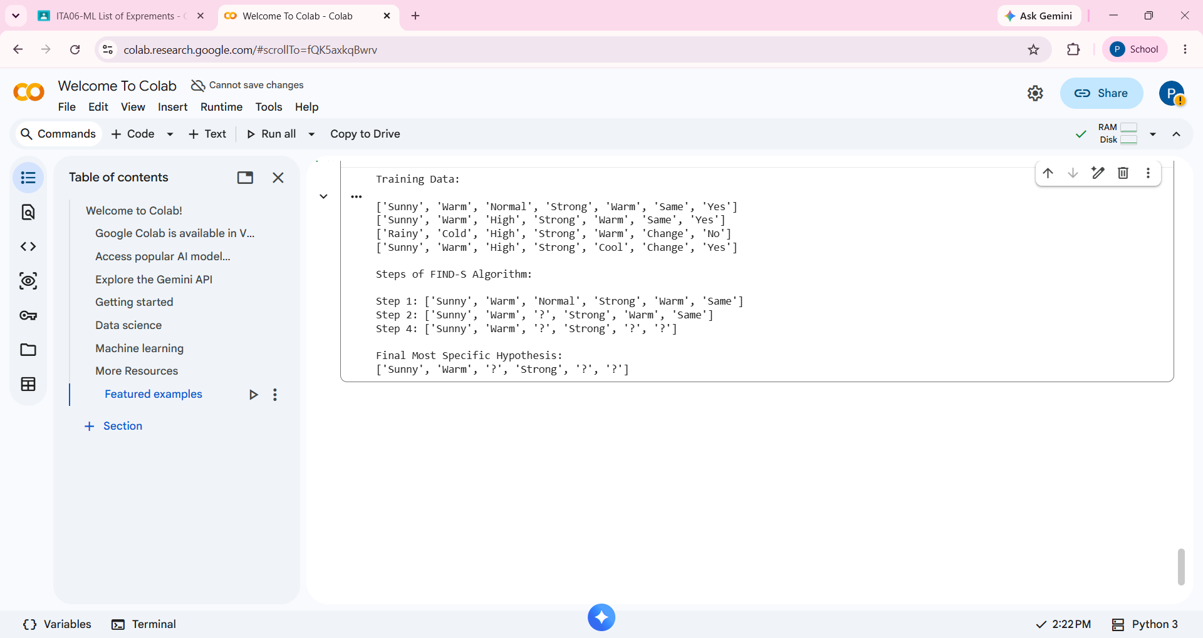
# Display Training Data
print("Training Data:\n")

for row in training_data:
print(row)
# FIND-S Algorithm
hypothesis = ['0'] * (len(training_data[0]) - 1)
print("\nSteps of FIND-S Algorithm:\n")
for i, sample in enumerate(training_data):
if sample[-1] == "Yes":
for j in range(len(hypothesis)):
if hypothesis[j] == '0':
hypothesis[j] = sample[j]
elif hypothesis[j] != sample[j]:
hypothesis[j] = '?'
print(f"Step {i+1}: {hypothesis}")
print("\nFinal Most Specific Hypothesis:")
print(hypothesis)

